CALL FOR PAPERS

Hybrid format: Campus of WU Vienna and online
17-18 March 2022
International Conference
“Green HRM and Sustainable Behavior: New Developments and Challenges”

This international conference on 17-18 March 2022 hosted by the Vienna University of Economics and Business (WU Vienna) and the University of Augsburg addresses new developments in and challenges for Green HRM and Sustainable Behavior in and of organizations. Since the research field of Green HRM and Sustainable Organizational Behavior has grown quickly, we aim to offer an opportunity for international scholars to present and discuss recent findings of their studies. In addition, this conference marks the end of our FWF/DFG funded project on “Comparative Green HRM” led by Michael Muller-Camen and Marcus Wagner.
We welcome high quality contributions and work-in-progress submissions across research fields and theoretical backgrounds that advance our understanding of current developments and challenges (e.g. tensions and paradoxes) in the context of Green HRM and Sustainable Behaviors in the workplace. Potential areas of interest include, but are not limited to:
- Theoretical and/or empirical contributions on recent developments and challenges in Green HRM practices and Sustainable Behavior
- Multi-level and comparative perspectives on Green HRM practices, Sustainable Behavior and their respective antecedents and outcomes
- Responses to challenges of Sustainable Behavior that materialize in tensions, contradictions or paradoxes of sustainability
- Nested and multi-level paradoxes that result from the inherent complexity of sustainability in a workplace context as well as preferences, norms, and (dis-)incentives for Sustainable Workplace Behaviors
- Mixed methods approaches for investigating Sustainable HRM/company policies, Sustainable Behaviors, and their interplay
- Research into the process and outcomes of determining key issues and policies for Strategic Green HRM within and between companies

Organizers:
WU Vienna and University of Augsburg: The Austrian Science Fund (FWF) and the German Research Foundation (DFG) fund the conference.

Scientific Committee:
Prof. Susan E. Jackson (Department of Human Resource Management, Rutgers - The State University of New Jersey)
Prof. Yuan Jiang (Harbin Institute of Technology)
Prof. Michael Müller-Camen (Institute for Human Resource Management, WU Vienna)
Prof. Pascal Paillé (NEOMA Business School)
Prof. Andrew Spicer (Darla Moore School of Business, University of South Carolina)
Prof. Shuang Ren (Deakin Business School, Deakin University)
Prof. Douglas Renwick (Nottingham Business School, Trent University)
Prof. Marcus Wagner (Faculty of Business Administration and Economics, University of Augsburg)
Prof. Maurizio Zollo (Department of Management and Entrepreneurship, Imperial College London)

Date:
Thursday, 17 March 2022 to Friday, 18 March 2022, 13.00 to 21.00 CET

Venue:
Online – The access details will be sent to your email address a few days prior to the event, and at the Campus of WU Vienna
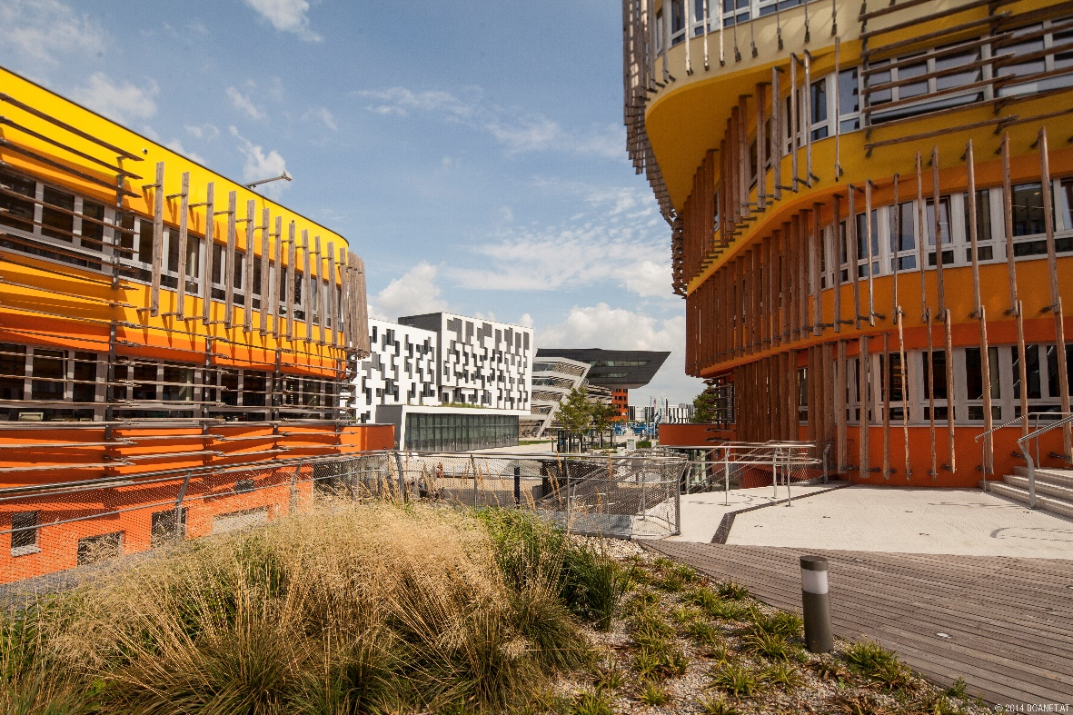

Paper Submission and Registration:
Please submit either a full paper or a short paper including a title page with title, author names and affiliations, 150-word abstract, and up to 5 key words. Submissions should follow a specific format (i.e., 12 pt, Times New Roman or Arial; margin left/right: 2.5 cm; line spacing: 1.5). The maximum length of a full paper is 40 pages and for a short paper 10 pages (including title page, all tables, graphs, figures, appendices, and references).

You can submit your paper from 1 September until 1 December 2021 by using the online form on our website: https://www.wu.ac.at/en/persm/green-hrm/konferenz-2022

https://www.wu.ac.at...

We will send out the submissions for peer-review and inform you in a timely manner if your paper is accepted for the conference.
The registration is open from 13 December until 20 February on our website. You will be asked to indicate if you will participate in person or online. More information on the registration will follow. Participation is free of charge.

For further information, please contact the two organizers michael.muller-camen@wu.ac.at or marcus.wagner@wiwi.uni-augsburg.de.

